Case Report — National Gallery DC

### 

### 

### Tracy’s iPhone [2012-07-15 National Gallery Case]

### 

### 

Report prepared by

Digitech, Inc.

— Forensic Analysts —

Matt Snowball, Bradley Ochilien, Vladimir Britvin,  
Natraj Venkat, Sabarevasan Subbrahmanian, Izabela Kozielec

# Table of Contents

Case Report

National Gallery DC

Tracy’s iPhone [2012-07-15-National-Gallery]

Table of Contents

Executive Summary

Equipment and Tools

Details of Tracy’s iPhone

Evidence to Establish Personas

Evidence relating to theft of valuable stamps

Evidence relating to defacement of museum art

Plot Timeline

Conclusion

Appendix A: Correspondence Evidence

Appendix B: WiFi and GPS Location Information

# Executive Summary

On January 21, 2016, Digitech Inc. was called in to assist the National Gallery, Washington D.C. (NGDC) case involving the conspiracy associated with the theft of valuable stamps and defacing of museums are at the NGDC.

* Tracy is a suspect in the aforementioned conspiracy
* As part of the investigation, Tracy’s iPhone was taken into custody
* Digitech, Inc. was tasked with investigating evidence relevant to the aforementioned conspiracy

As described fully in the report, Digitech, Inc. made the following findings:

1. Digitech, Inc found evidence to suggest that Tracy is using an alias “King”

1. Alex is a Krasnovian supporter who wishes to embarrass the United States. He lives outside the United States, presumably in a region called Krasnovia.  
   1. He knows Carry through extended family connections, and contacts her.
   2. He plans to deface foreign works that are on exhibit at the National Gallery in DC. Defacing the artwork will embarrass the United States and possibly degrade the relationship between the United States and the foreign country.
2. Carry is a somewhat criminally involved individual and Krasnovian supporter who shares family ties with Alex.  
   1. Carry is tech savvy and an occasional social media user. She is contacted by Alex in the beginning of the scenario and asked to orchestrate the defacing of the artwork because she is both aligned with Krasnovia and has "connections".
   2. She is acquainted with Tracy
3. Tracy works as a supervisor at the National Gallery.  
   1. Carry contacts Tracy and starts sending her small pieces of data, telling Tracy that she wants to organize a flash mob at the gallery and needs a little help.
   2. Carry offers to give Tracy money for this help. The items transferred are suspicious but not outright illegal. Tracy is having trouble with finances and this allows her to overlook the suspicious nature of the requests.
4. Joe is currently going through a divorce with Tracy.  
   1. Joe is financially well-off and still bitter about the issues in their marriage.
   2. Now that Joe and Tracy are going through a divorce, he has motivation to use the keylogger to spy on both Tracy and Terry, their daughter.
   3. He previously installed a keylogger on the family's MacBook Air in an attempt to keep track of Terry's online behavior.
   4. Joe used to have an account on the MacBook Air, but it was deleted. The home folder may have been preserved.
5. Pat is a police officer in the D.C. Enforcers Bureau and Tracy's brother. He holds the status of detective and is very devoted to his sister and his niece Terry.

### Equipment and Tools

The seized evidence included an iPhone and a tablet. The copy of the device storage contains operating system data, file system data, applications, documents, pictures, videos, and music.

Digitech,Inc. looked for evidence related to the case, including:

* + SMS messages that show intent to commit a crime
  + IP address information that indicates GPS location data alongside timestamp
  + Emails and email addresses that contain incriminating evidence

EQUIPMENT: FLASH MEMORY

Following equipment was used in this investigation:

**An iPhone (Flash memory) drive**

* Flash Storage devices have no moving parts and use flash memory, allowing for quicker read and write access. Flash memory or flash storage is **non-volatile**, meaning it holds data even when it's not connected to power. This technology is used in devices such as USB drives, mobile phones, cameras, and tablet computers.

In an iPhone, this will recover deleted messages as well as GPS coordinates and cell tower locations.

Data on confiscated equipment, such as:

* + - Emails
    - Images
    - Text messages
    - Phone logs
    - Browsing history

The following directories contain evidence applicable to the Tracy iPhone investigation:

/mobile

/Applications

/Library

/root

/Logs

/logs

* Phones allow users to back up their data to the cloud, which could be another source of data in an investigation. During an investigation, we maintain integrity of data making sure that evidence is not contaminated. Our team of forensic investigators **imaged** the data.

IMPORTANT!

To preserve the integrity of digital evidence, **a bit-level copy**, not the original media, was used by Digitech, Inc. for analysis.

**A bit-level copy**

* **A bit-stream image** captures all created sections of a hard drive, known as partitions, whether used or not, and all unallocated drive space that doesn’t belong to partitions.  
  This method allows our team of forensic examiners to recover deleted files and fragments of data that may exist on a hard drive.  
  A bit-level copy or bit-stream image copies over everything slack space, deleted files, and the regular files as well.

TOOLS:

The following tools were used in this investigation:

* Autopsy 4.16.0 Digital Forensics Suite [Sleuthkit Autopsy Forensic Application](https://sleuthkit.org/autopsy/docs/user-docs/4.3/index.html)

Autopsy is an open source graphical interface to The Sleuth Kit and other digital forensics tools.[1]

* SQLite DB Browser [DB Browser for SQLite](https://sqlitebrowser.org/)

DB Browser for SQLite (DB4S) is a high quality, visual, open source tool to create, design, and edit database files compatible with SQLite.[2]

* Google Earth [Google Earth](https://www.google.com/earth/)

Create stories and maps.[3]

* Epoch Converter [Epoch Converter - Unix Timestamp Converter](https://www.epochconverter.com/)

Easy epoch/Unix timestamp converter for computer programmers. Includes epoch explanation and conversion syntax [4]

* Identify Mobile Device  [IMEI.com](https://www.imei.info/news/your-imei-number-will-tell-you-everything-about-your-iphone/)  
  International Mobile Equipment Identification (IMEI) number  
  **Tracy Sumtwelve’s iPhone(IMEI) number: 012021003735398**<https://www.imei.info/?imei=012021003735398>

Each Apple product is associated with its own unique identification number, known as an International Mobile Station Equipment Identity IMEI.  
It bears detailed information about the phone, such as its model, brand, production date, and the manufacturer's site. The IMEI number or in other words International Mobile Equipment Identity is a unique 15-digit code that precisely identifies the device with the SIM card.[5]

* Integrated Circuit Card ID Integrated Circuit Card ID (ICCID) [hologram.io](https://hologram.io/blog/whats-an-iccid-number-and-why-does-it-matter-for-cellular-iot/)  
  The integrated circuit card ID (ICCID) is a unique 19- or 20-digit number printed on a SIM card used to identify the card. The ICCID is a globally unique serial number—a one-of-a-kind signature.[6]

# Details of Tracy’s iPhone

tracy-phone-2012-07-15-final.EO1

|  |  |  |
| --- | --- | --- |
| Image: tracy-phone-2012-07-15-final.EO1 | | |
|  | Findings | Location in Image File |
| Model | iPhone1,2 | vol_vol5/mobile/Library/Logs/AppleSupport/general.log |
| Host Name | Tracy Sumtwelve’s iPhone | vol_vol5/logs/lockdownd.log.1 |
| OS Version | iPhone OS 4.2.1 (8C148) | vol_vol5/mobile/Library/Logs/AppleSupport/general.log |
| Install Time | 6/6/2012 19:03:28 | vol_vol5/mobile/Library/Logs/AppleSupport/general.log |
| User Email(s) | tracysumtwelve@gmail.com  coralbluetwo@gmail.com | vol_vol5/mobile/Library/Mail  vol_vol5/Keychains/kechain-2.db |
| Phone Number | (703) 340-9661 | vol_vol5/logs/lockdownd.log.1 |
| Serial Number | 86004482Y7H | vol_vol5/mobile/Library/Logs/AppleSupport/general.log |
| ICCID | 89014103255195342366 | vol_vol5/logs/lockdownd.log.1 |
| IMEI | 012021003735398 | vol_vol5/root/Library/Lockdown/activation_records/wildcard_record.plist |
| Phone Image Hashes | | |
| MD5 | 34c4888f095dc3241330462923f6fea5 | |
| SHA256 | 71aed05a86a753dec4ef4033ed7f52d6577ccb534ca0d1e83ffd27683e621607 | |

# 

# Evidence to Establish Personas

This section establishes aliases, phone numbers, email addresses associated with each person, and relationships between each individual.

Tracy: alias: Coral Bluetwo

Phone Number: (703) 340-9661

Personal Email: [tracysumtwelve@gmail.com](mailto:tracysumtwelve@gmail.com)

[coralbluetwo@hotmail.com](mailto:coralbluetwo@hotmail.com)

Work Email: [tracy.sumtwelve@nationalgallerydc.org](mailto:tracy.sumtwelve@nationalgallerydc.org)

Relationship: Tracy works as a supervisor at the National Gallery is the accused

Pat: alias: Perry Patsum

Phone Number: (571) 308-3236

Email: [perrypatsum@yahoo.com](mailto:perrypatsum@yahoo.com)

[patsumtwelve@gmail.com](mailto:patsumtwelve@gmail.com)

Relationship: Pat is a police officer in the D.C. Enforcers Bureau and Tracy's brother. He holds the status of detective and is very devoted to his sister and his niece Terry.

Terry:

Phone Number: +1 (703) 829 6071

Email:N/A

Relationship: Terry is the daughter of Tracy and Joe

Joe:

Phone Number: N/A

Email: [joe.sum.twelve@gmail.com](mailto:joe.sum.twelve@gmail.com)

Relationship: Ex-Husband of Tracy and is currently going through a divorce.

Carry:

Phone Number: (202) 725-2124

Email: [carrysum2012@yahoo.com](mailto:carrysum2012@yahoo.com)

Relationship: Carry is the defacer and is criminally involved individually and a Krasnovian supporter who shares family ties with Alex

King: King kthings

Email: [throne1966@hotmail.com](mailto:throne1966@hotmail.com)

Relationship: Criminal hired by Pat Patsum, Tracy’s brother holds the status of detective and is very devoted to his sister and his niece Terry.

Please refer to artifacts Appendix A and B (see below) to support the conclusions of Digitech Inc..

# Evidence relating to theft of valuable stamps

This sub-section provides details regarding the evidence found as it relates to the theft of valuable stamps.

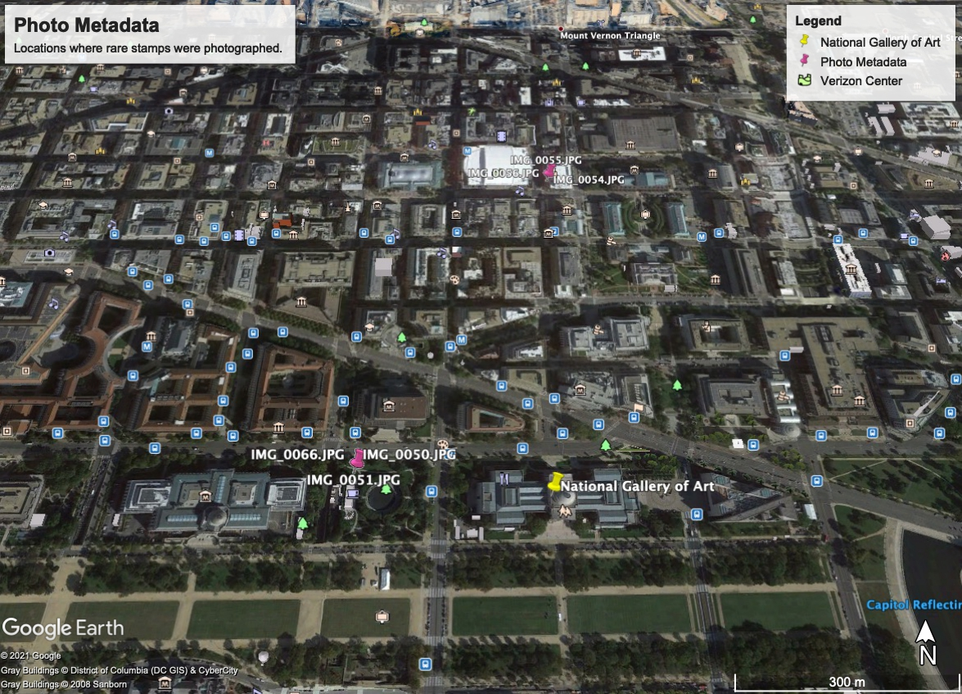

There is clear mention of a heist being planned at the National Gallery and also references an attachment “needs.txt” that contains the listing of tools that they need to execute this heist.

|  |  |  |  |  |
| --- | --- | --- | --- | --- |
| Photographic Evidence of Stamps | | | | |
| Artifact # | Timestamp | Filename | Lat, Long, Alt | Image |
| /img_tracy-phone-2012-07-15-final.E01/vol_vol5/mobile/Media/DCIM/100APPLE/ | | | | |
| 43389 | 2012-07-08 12:37:38 EDT | IMG_0048.JPG | At National Gallery entrance |  |
| 43392 | 2012-07-08 12:41:41 EDT | IMG_0049.JPG | 38.89166667, -77.0235, 78.04526749  Near National Gallery Sculpture Garden |  |
| 43394 | 2012-07-08 12:41:53 EDT | IMG_0050.JPG | 38.89166667, -77.0235, 78.04526749  Near National Gallery Sculpture Garden |  |
| 43396 | 2012-07-08 12:42:03 EDT | IMG_0051.JPG | 38.89166667, -77.0235, 78.04526749  Near National Gallery Sculpture Garden |  |
| 43402 | 2012-07-08 12:49:25 EDT | IMG_0054.JPG | 38.89766667, -77.01966667,  N/A  Near Verizon Centre |  |
| 43404 | 2012-07-08 12:49:37 EDT | IMG_0055.JPG | 38.89766667, -77.01966667,  N/A  Near Verizon Centre |  |
| 43406 | 2012-07-08 12:49:49 EDT | IMG_0056.JPG | 38.89766667, -77.01966667,  N/A  Near Verizon Centre |  |
| 43408 | 2012-07-08 12:50:07 EDT | IMG_0057.JPG | 38.89766667, -77.01966667,  N/A  Near Verizon Centre |  |
| 43410 | 2012-07-08 12:50:20 EDT | IMG_0058.JPG | 38.89766667, -77.01966667,  N/A  Near Verizon Centre |  |
| 43412 | 2012-07-08 12:50:34 EDT | IMG_0059.JPG | N/A |  |
| 43414 | 2012-07-08 12:50:50 EDT | IMG_0060.JPG | N/A |  |
| 43416 | 2012-07-08 12:50:53 EDT | IMG_0061.JPG | N/A |  |
| 43418 | 2012-07-08 12:51:03 EDT | IMG_0062.JPG | N/A |  |
| 43420 | 2012-07-08 12:51:14 EDT | IMG_0063.JPG | N/A |  |
| 43424 | 2012-07-08 12:59:55 EDT | IMG_0065.JPG | 38.89166667, -77.0235, 78.04526749  Near National Gallery Sculpture Garden |  |
| 43426 | 2012-07-08 13:00:01 EDT | IMG_0066.JPG | 38.89166667, -77.0235, 78.04526749  Near National Gallery Sculpture Garden |  |
| 43428 | 2012-07-08 13:00:07 EDT | IMG_0067.JPG | 38.89166667, -77.0235, 78.04526749  Near National Gallery Sculpture Garden |  |
| 43430 | 2012-07-08 13:00:12 EDT | IMG_0068.JPG | 38.89166667, -77.0235, 78.04526749  Near National Gallery Sculpture Garden |  |
| 43432 | 2012-07-08 13:00:23 EDT | IMG_0069.JPG | 38.89166667, -77.0235, 78.04526749  Near National Gallery Sculpture Garden |  |
| /img_tracy-phone-2012-07-15-final.E01/vol_vol5//$CarvedFiles/ | | | | |
| 154031 | 2012-06-15 15:30:30 EDT | f0455920.jpg | N/A |  |

### Data carving is the process whereby raw data is assembled and matched to known file type patterns to aid in extraction.[7]

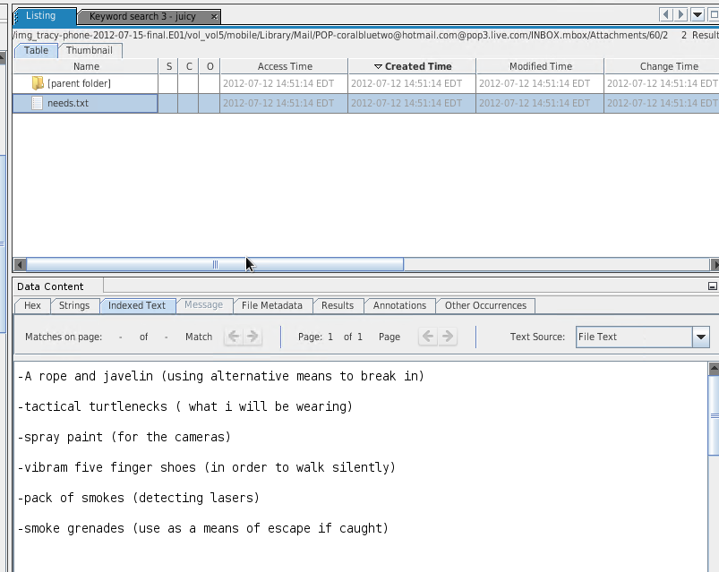

To support conclusion that Tracy is clearly planning heist at the National Gallery in an email Subject: “can’t pass up”, Tracy [coralbluetwo@hotmail.com](mailto:coralbluetwo@hotmail.com) was copied from Pat (police officer) [patsumtwelve@gmail.com](mailto:patsumtwelve@gmail.com) a message to criminal alias King kthings [throne1966@hotmail.com](mailto:throne1966@hotmail.com).

See Appendix A Correspondence Evidence.

Please refer to artifacts Appendix A and B (see below) to support Digitech Inc conclusions.

# Evidence relating to defacement of museum art

This sub-section provides details regarding the evidence found as it relates to the defacement of museum art.

The evidence relating to the defacement of museum art is found in the mail (9F0508B8-04FB-A7F0-3E23B0E7C59B.emlx) received on 10th July 2012 at 08:24:57 PDT by Pat <[patsumtwelve@gmail.com](mailto:patsumtwelve@gmail.com)> to coral <[coralbluetwelve@hotmail.com](mailto:coralbluetwelve@hotmail.com)> with the subject “Fwd: can’t pass up”.

We found both these pieces of evidence under the following path:

/img_tracy_phone-2012-07-15-final.E01/vol_vol5/mobile/Library/Mail/

Please refer to artifacts Appendix A and B (see below) to support Digitech Inc S conclusions.

Plot Timeline

Carry’s messages and timeline

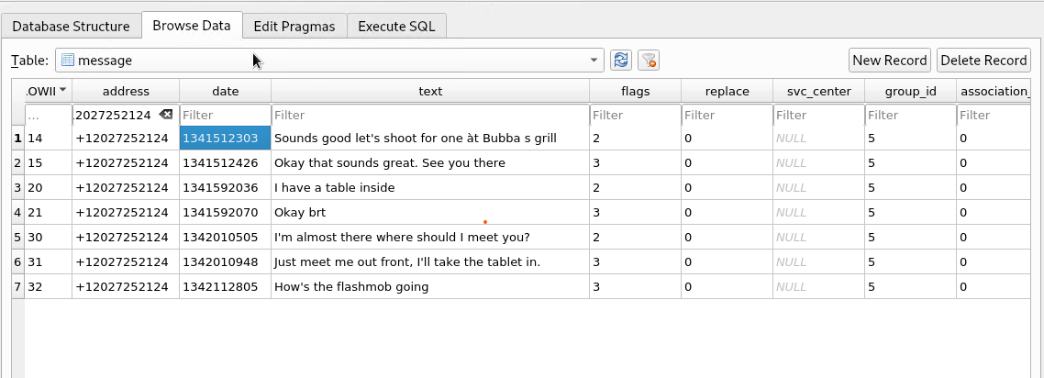

|  |  |  |
| --- | --- | --- |
| **Epoch date** | **GMT** | **EDT** |
| 1341541303 | 2012-07-06 02:38:23 | 2012-07-05 22:38:23 |
| 1341542426 | 2012-07-06 02:40:26 | 2012-07-05 22:40:26 |
| 1341592036 | 2012-07-06 16:27:16 | 2012-07-06 12:27:16 |
| 1341592070 | 2012-07-06 16:27:50 | 2012-07-06 12:27:50 |
| 1342010505 | 2012-07-11 12:41:45 | 2012-07-11 08:41:45 |
| 1342010948 | 2012-07-11 12:49:08 | 2012-07-11 08:49:08 |
| 1342112805 | 2012-07-12 17:06:45 | 2012-07-12 13:06:45 |

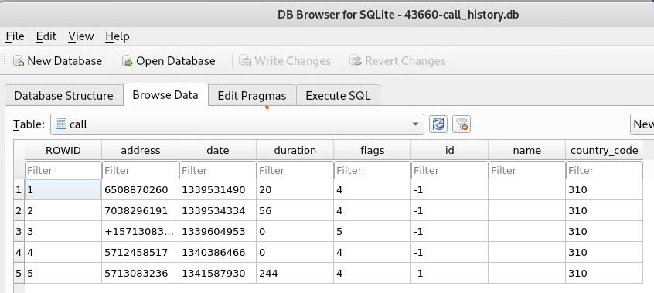

|  |  |  |
| --- | --- | --- |
| **Epoch date** | **GMT** | **EDT** |
| 1339531490 | 2012-06-12 20:04:50 | 2012-06-12 16:04:50 |
| 1339534334 | 2012-06-12 20:52:14 | 2012-06-12 16:52:14 |
| 1339604953 | 2012-06-13 16:29:13 | 2012-06-13 12:29:13 |
| 1340386466 | 2012-06-22 17:34:26 | 2012-06-22 13:34:26 |
| 1341587930 | 2012-07-06 15:18:50 | 2012-07-06 11:18:50 |

Possible username/password combination to obtain further data:

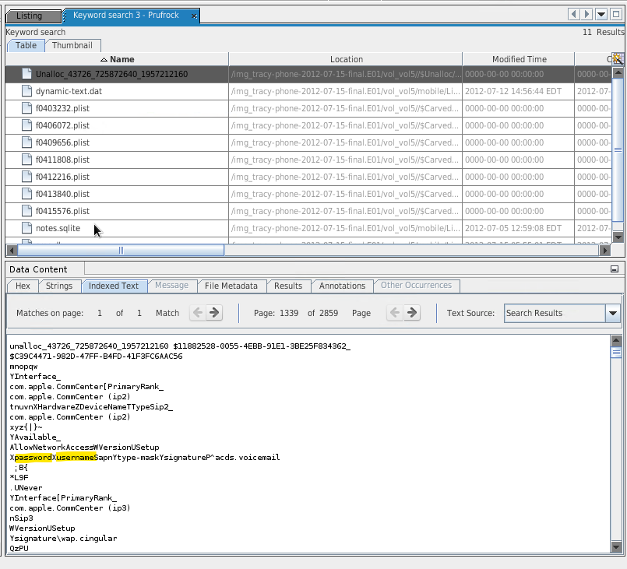

# Conclusion

Evidence found on Tracy’s iPhone indicated the following:

Relevant case file data and established Tracy Sumtwelve’s ownership of a device. Tracy’s alias Coral, her phone is clearly used to communicate about a heist being planned at the National Gallery and also references an attachment “needs.txt” that contains the listing of tools that they need to execute this heist.

Tracy Sumtwelve’s MD5 and SHA-265 hashes of the iPhone disk image:

MD5 hash: 34c4888f095dc3241330462923f6fea5

SHA-256 hash: 71aed05a86a753dec4ef4033ed7f52d6577ccb534ca0d1e83ffd27683e621607

Tracy’s device Information:

Device model: iPhone (1-2)

Autopsy was not able to successfully determine the version of the iPhone. It was between Version 1 and Version 2.

Device host name: Tracy Sumtwelve’s iPhone

OS version #: iPhone OS 4.2.1 (8C148)

Install time: 6/6/2012 19:03:28

Device serial #: 86004482Y7H

Located In: /mobile/Library/Logs/AppleSupport/general.log

Tracy’s Phone’s Integrated Circuit Card ID (ICCID) number:

89014103255195342366

Located in: /logs/lockdownd.log.1

Tracy’s Phone’s International Mobile Equipment Identification (IMEI) number:

012021003735398  
<https://www.imei.info/?imei=012021003735398>

Located in: /root/Library/Lockdown/activation_records/wildcard_record.plist

Tracy's information:

Tracy's phone number: (703) 340-9661

Tracy's email addresses:

tracysumtwelve@gmail.com, tracysumtwelve@nationalgallergydc.org

Located in: vol5/mobile/Library/Mail

# 

# Appendix A: Correspondence Evidence

This subsection will provide an amalgamation of the email and SMS corresponce evidence. The file found at: /img_tracy-phone-2012-07-15-final.E01//vol5/mobile/Library/Mail/POP/INBOX.mbox/Messages

# Correspondence Evidence

### 

|  |  |  |  |  |
| --- | --- | --- | --- | --- |
| Master Timeline of NGDC | | | | |
| Artifact # | Timestamp | Header Information | Key Information | Evidence Location |
| 01FE9965-A923-40CF-A78A-72CE3BD26571.emlx | Wed, 11 Jul 2012  04:18:33 | Subject: Only 30 days left!  Start a free Office training course | You’re halfway through your trial. Increase your productivity at home and work with free Office training.  Days remaining in your Office 2010 trial: 30 | /casedata/2012-07-15 National-Gallery/Export/43149-INBOX.mbox/Messages |
| 3896FC6F-A083-4D39-B0A2-CE68368D44CA.emlx | Tue, 19 Jun 2012 14:39:04 | Received from: 8.30.72.30 web120402.mail.ne1.yahoo.com  From: Perry Patsum  perrypatsum@yahoo.com  Subject: Crazydave by the VMs  To: Coral Bluetwo  coralbluetwo@hotmail.com | Hey Coral, Just got your email. That took longer than expected! Oh well! You’ve got to check out this new song by the VMs. I love the base. Tell me what you think!  Attachment:  Crazydave1.mp3 | /casedata/2012-07-15 National-Gallery/Export/43149-INBOX.mbox/Messages |
| 8A3BD06F-CDB1-4453-9C69-77E06823F2AE.emlx | Mon, 9 Jul 2012 07:47:58 | Received from: 209.85.216.171 mail-qc0-f171.google.com  From: Tracy Sumtwelve  [tracysumtwelve@gmail.com](mailto:tracysumtwelve@gmail.com)  Subject: things  To: [coralbluetwo@hotmail.com](mailto:coralbluetwo@hotmail.com) | Attachment:  Documents.zip  Encoding: base 64 | /casedata/2012-07-15 National-Gallery/Export/43149-INBOX.mbox/Messages |
| 9F0508B8-04FB-490E-A7F0-3E23B0E7C59B.emlx | Tue, 10 Jul 2012 08:24:58 | Received from: 209.85.214.180  Mail-ob0-f180.google.com  From: [patsumtwelve@gmail.com](mailto:patsumtwelve@gmail.com)  Subject: can’t pass up  To: [coralbluetwo@hotmail.com](mailto:coralbluetwo@hotmail.com) | This is what we need to get for the guy that's going to make our job happen | /casedata/2012-07-15 National-Gallery/Export/43149-INBOX.mbox/Messages |
| 9F0508B8-04FB-490E-A7F0-3E23B0E7C59B.emlx | Tue, 10 Jul 2012  11:19 | Forwarded message: RE: can’t pass up  From: King kthings  [throne1966@hotmail.com](mailto:throne1966@hotmail.com)  Subject: can’t pass up  To: [patsumtwelve@gmail.com](mailto:patsumtwelve@gmail.com) | You’re too kind… I got you brotha. I need some tools in order to do this job for you. Here are some requirements that i will need: see attachment | /casedata/2012-07-15 National-Gallery/Export/43149-INBOX.mbox/Messages |
| 9F0508B8-04FB-490E-A7F0-3E23B0E7C59B.emlx | Fri, 6 Jul 2012  11:49:31 | Forwarded message: RE: can’t pass up  From [patsumtwelve@gmail.com](mailto:patsumtwelve@gmail.com)  Subject: can’t pass up  To: [throne1966@hotmail.com](mailto:throne1966@hotmail.com)  CC: [coralbluetwo@hotmail.com](mailto:coralbluetwo@hotmail.com) | King,  Long time no see… I have a juicy proposition for you. Two weeks from now, me and my associates are planning a heist at the national gallery.  Although, we need a helping hand. I know that you are on parole right now and are probably hesitant to participate. Me and your parole officer go years back. He is a very strict fellow. If we were to find out that you were dealing with drugs and shooting dope in your veins every night, i feel he wouldn=92t be too happy. It=92s very easy for a person to phone the feds an anonymous tip that you are on drugs and the location of your stash. All they have to do is give you a drug test and since you’re on parole, the feds don=92t need a search warrant. Well hit me up. You know where to find me.  Attachment: needs.txt | /casedata/2012-07-15 National-Gallery/Export/43149-INBOX.mbox/Messages |
| F3F4EB95-52EB-42FC-9279-46DAB24B6E34.emlx | Thu, 5 Jul 2012 12:58:42 | Received from: 208.97.132.83  Homiemail-a15.g.dreamhost.com  From: [Woina.Honril@m57.biz](mailto:Woina.Honril@m57.biz)  To: [coralbluetwo@hotmail.com](mailto:coralbluetwo@hotmail.com)  Subject: Busy | I didn’t.  Attachment: 000001.doc | /casedata/2012-07-15 National-Gallery/Export/43149-INBOX.mbox/Messages |

### 

# Appendix B: WiFi and GPS Location Information

WiFi and GPS location information were found at:

/img_tracy-phone-2012-07-15-final.E01/vol_vol5/root/Library/Caches/location/consolidated.db

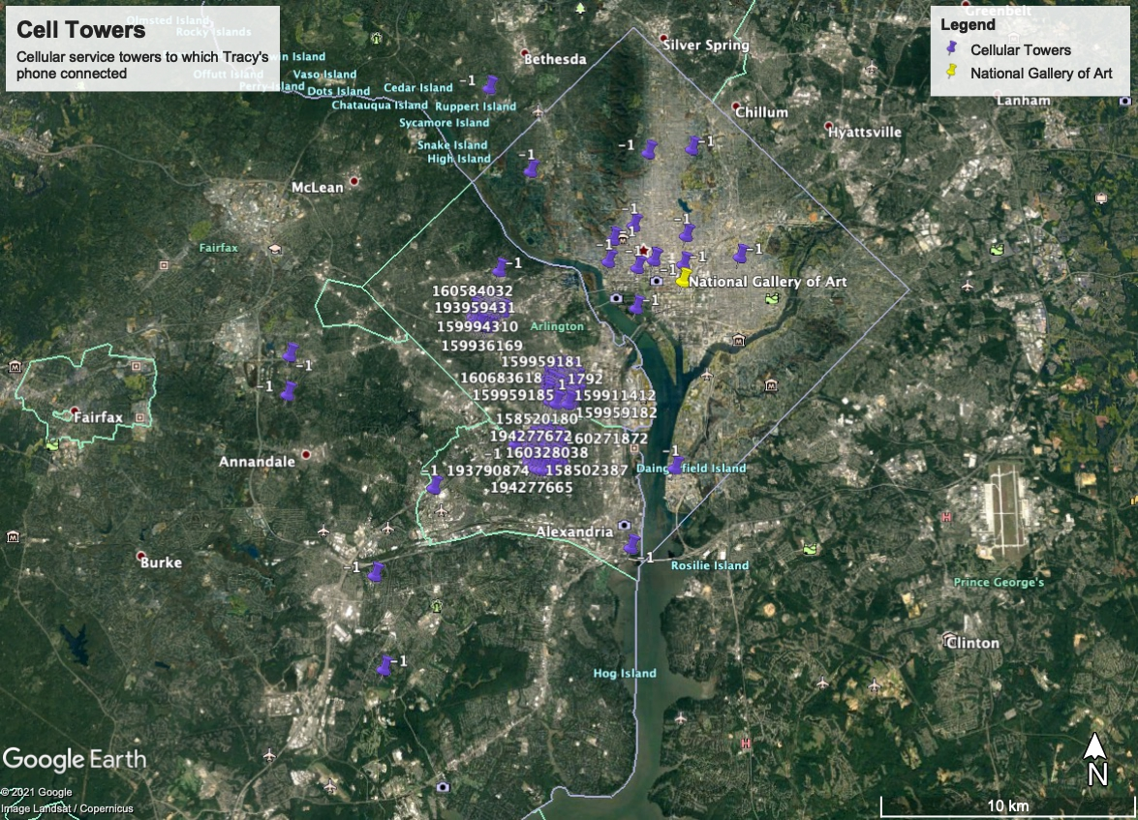

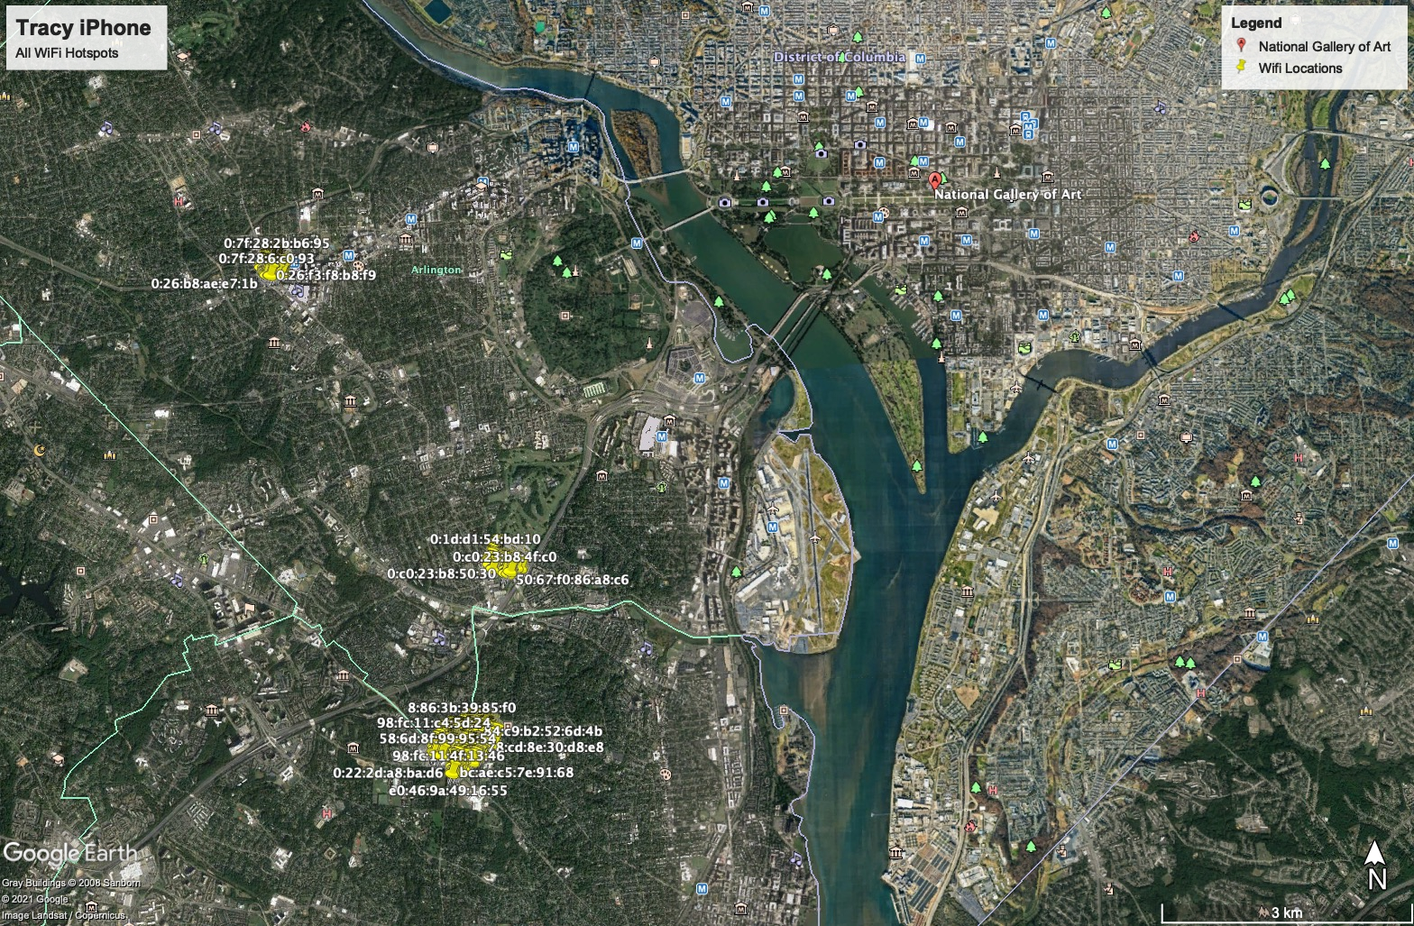

|  |  |  |  |  |
| --- | --- | --- | --- | --- |
| Location Information | | | | |
| Artifact # | Timestamp | Header Information | Body | Map Screenshot |
| 1 | 2012-07-03 1:42:43 PM | 38°52'48.8"N 77°06'56.0"W | 800 N Glebe Rd, Arlington, VA 22203  0:1d:d1:b:96:90 3.63015762683134E8 38.88021385 -77.11556154 46.0 123.0 39.0 -1.0 -1.0 50 |  |
| 2 | 2012-06-13 7:04:04 PM | 38°52'52.8"N 77°06'50.4"W | 900 N Taylor St, Arlington, VA 22203  68:7f:74:94:aa:ed 3.61307043743548E8 38.88133615 -77.11399537 58.0 132.0 37.0 -1.0 -1.0 50 |  |
| 3 | 2012-07-05 4:32:48 PM | 38°52'49.2"N 77°06'51.5"W | 900 N Glebe Rd, Arlington, VA 22203  0:b:6c:bb:b0:5 3.63198767554628E8 38.88033336 -77.11429077 48.0 112.0 19.0 -1.0 -1.0 50 |  |
| 4 | 2012-07-05 4:32:48 PM | 38°52'51.9"N 77°06'54.0"W | 901 N Glebe Rd, Arlington, VA 22203  0:26:b8:b5:b2:6d 3.63198767554628E8 38.88109195 -77.11499398 66.0 124.0 35.0 -1.0 -1.0 50 |  |
| 5 | 2012-07-10 4:31:12 PM | 38°50'56.3"N 77°04'54.2"W | 2400 S Glebe Rd, Arlington, VA 22206  c:d5:2:af:6:da 3.63630672185595E8 38.84897792 -77.08172118 56.0 49.0 16.0 -1.0 -1.0 50 |  |
| 6 | 2012-07-10 4:46:30 PM | 38°49'40.5"N 77°05'11.4"W | 1333 N Quaker Ln, Alexandria, VA 22302  2c:b0:5d:82:fd:c2 3.63631589748528E8 38.82791513 -77.08650749 80.0 70.0 13.0 -1.0 -1.0 50 |  |
| 7 | 2012-07-05 4:32:46 PM | 38°52'56.0"N 77°06'54.0"W | 1000 N Vermont St, Arlington, VA 22201  310 410 7985 159922035 3.63198766054534E8 38.8822233 -77.11500936 2341.0 0.0 -1.0 -1.0 -1.0 50 |  |
| 8 | 2012-07-10 4:45:00 PM | 38°49'14.1"N 77°04'59.5"W | Taylor Run, Alexandria, VA  310 410 7980 160328038 3.63631499997881E8 38.82058799 -77.08318334 1450.0 0.0 -1.0 -1.0 -1.0 50 |  |

1. "The Sleuth Kit (TSK) & Autopsy: Open Source Digital Forensics Tools." <https://www.sleuthkit.org/>. Accessed 4 Mar. 2021.
2. "DB Browser for SQLite." <https://sqlitebrowser.org/>. Accessed 4 Mar. 2021.
3. "Google Earth." <https://www.google.com/earth/>. Accessed 4 Mar. 2021.
4. "Epoch Converter - Unix Timestamp Converter." <https://www.epochconverter.com/>. Accessed 4 Mar. 2021.
5. "IMEI.info: IMEI CHECK - Free Online IMEI Number Checker." <https://www.imei.info/>. Accessed 4 Mar. 2021.
6. "What is an ICCID Number and Why Does It Matter for Cellular IoT ...." 2 Dec. 2019, <https://www.hologram.io/blog/whats-an-iccid-number-and-why-does-it-matter-for-cellular-iot>. Accessed 4 Mar. 2021.
7. “A Survey On Data Carving In Digital Forensics.” 1st May 2017, <https://www.forensicfocus.com/articles/a-survey-on-data-carving-in-digital-forensics/>, accessed on Mar 9, 2021